COMMON COURSE ASSIGNMENT FORMAT

- Assignment Information

Particular | Details
Department: | Department of Computer Science and Engineering
Programme: | B.E- Computer science and Engineering with Artificial Intelligence
Course Code & Course Name | CSA0702- Computer Networks
Academic Year / Batch | 2026-2027
Faculty Name | Dr. R. SENTHAMIL SELVAN B.E,M.Tech(CS),M.Tech(CSE), Phd,MISTE,FIETE
Assignment Title | Design a VLAN-based Enterprise LAN containing separate VLANs for Administration, Faculty, Students, and Guests
Date of Issue | 31/08/2026
Date of Submission | 1/09/2026
Maximum Marks | 100
Course Outcome(s) – CO | CO1, CO2, CO3, CO4, CO5
Bloom's Taxonomy Level | L3 – Apply / L4 – Analyze
SDG Mapping (SDG 1-17) | SDG 9 – Industry, Innovation and Infrastructure
Industry / Societal Relevance | VLAN-based network segmentation improves security, traffic management, scalability and efficient resource sharing in enterprises.

B. Assignment Problem / Challenge
Problem Statemen
Design and configure an enterprise Local Area Network (LAN) using VLANs to logically separate four departments:
- VLAN 10 – Administration
- VLAN 20 – Faculty
- VLAN 30 – Students
- VLAN 40 – Guests
The network should use VLAN segmentation to improve security, traffic management and network organization. The configured VLANs must be verified using suitable connectivity tests such as ping.

C. Problem Statement
Problem / Case / Design Challenge
An organization has a single LAN containing Administration, Faculty, Students and Guests. Using one common network can cause unnecessary broadcast traffic and security issues.
Therefore, an enterprise LAN is designed using VLANs so that each group operates in a separate logical network.
Expected Outcome
The proposed network should:
- Create four separate VLANs.
- Assign appropriate switch ports to each VLAN.
- Configure an appropriate IP addressing scheme.
- Configure trunk communication between network devices where required.
- Verify communication within the VLANs.
- Verify communication between VLANs using inter-VLAN routing, if configured.
- Provide better security and traffic isolation.

D. Requirements and Constraints
Functional Requirements
- Four VLANs must be created.
- Each department must have a separate VLAN.
- End devices must be assigned to the correct VLAN.
- Switch ports must be configured properly.
- Trunk links must carry multiple VLANs.
- Connectivity must be tested using ping.

Technical Requirements
Device | Quantity
Router / Layer-3 Switch | 1
Switch | 1 or more
Administration PCs | 2
Faculty PCs | 2
Student PCs | 2
Guest PCs | 2
Ethernet cables | Required

VLAN and IP Addressing

VLAN | Department | Network | Example Gateway
10 | Administration | 192.168.10.0/24 | 192.168.10.1
20 | Faculty | 192.168.20.0/24 | 192.168.20.1
30 | Students | 192.168.30.0/24 | 192.168.30.1
40 | Guests | 192.168.40.0/24 | 192.168.40.1

Constraints
- Different departments should remain logically separated.
- Correct VLAN IDs must be used.
- IP addresses must not conflict.
- Trunk ports must be configured correctly.
- Guest access should be restricted from sensitive internal networks in a real enterprise deployment.

Student Work
1. Problem Understanding and Formulation

What is the problem?

The problem is to design an enterprise LAN where Administration, Faculty, Students and Guests are separated using VLANs.

What are the expected outcomes?
The expected outcomes are:
- Proper VLAN segmentation.
- Reduced broadcast traffic.
- Improved network security.
- Easy network management.
- Successful communication testing.

Available Information
Four departments are given:
- Administration
- Faculty
- Students
- Guests
Each department is assigned a unique VLAN and IP subnet.

Assumptions

- Ethernet switches support VLAN configuration.
- The router or Layer-3 switch supports inter-VLAN routing.
- End devices have valid IP addresses.
- Network cables are properly connected.

2. Application of Course Knowledge

Relevant Networking Concepts

VLAN
A Virtual Local Area Network (VLAN) logically divides a physical LAN into multiple separate broadcast domains.

Access Port
An access port belongs to a single VLAN and is normally connected to an end device such as a PC.

Trunk Port
A trunk port carries traffic from multiple VLANs between network devices.

Inter-VLAN Routing
Inter-VLAN routing allows devices belonging to different VLANs to communicate through a router or Layer-3 switch.

Subnetting
Each VLAN is assigned a separate subnet:
- VLAN 10 → 192.168.10.0/24
- VLAN 20 → 192.168.20.0/24
- VLAN 30 → 192.168.30.0/24
- VLAN 40 → 192.168.40.0/24
For /24:
Subnet mask = 255.255.255.0
Each subnet provides 254 usable host addresses.

3. Solution / Design / Methodology
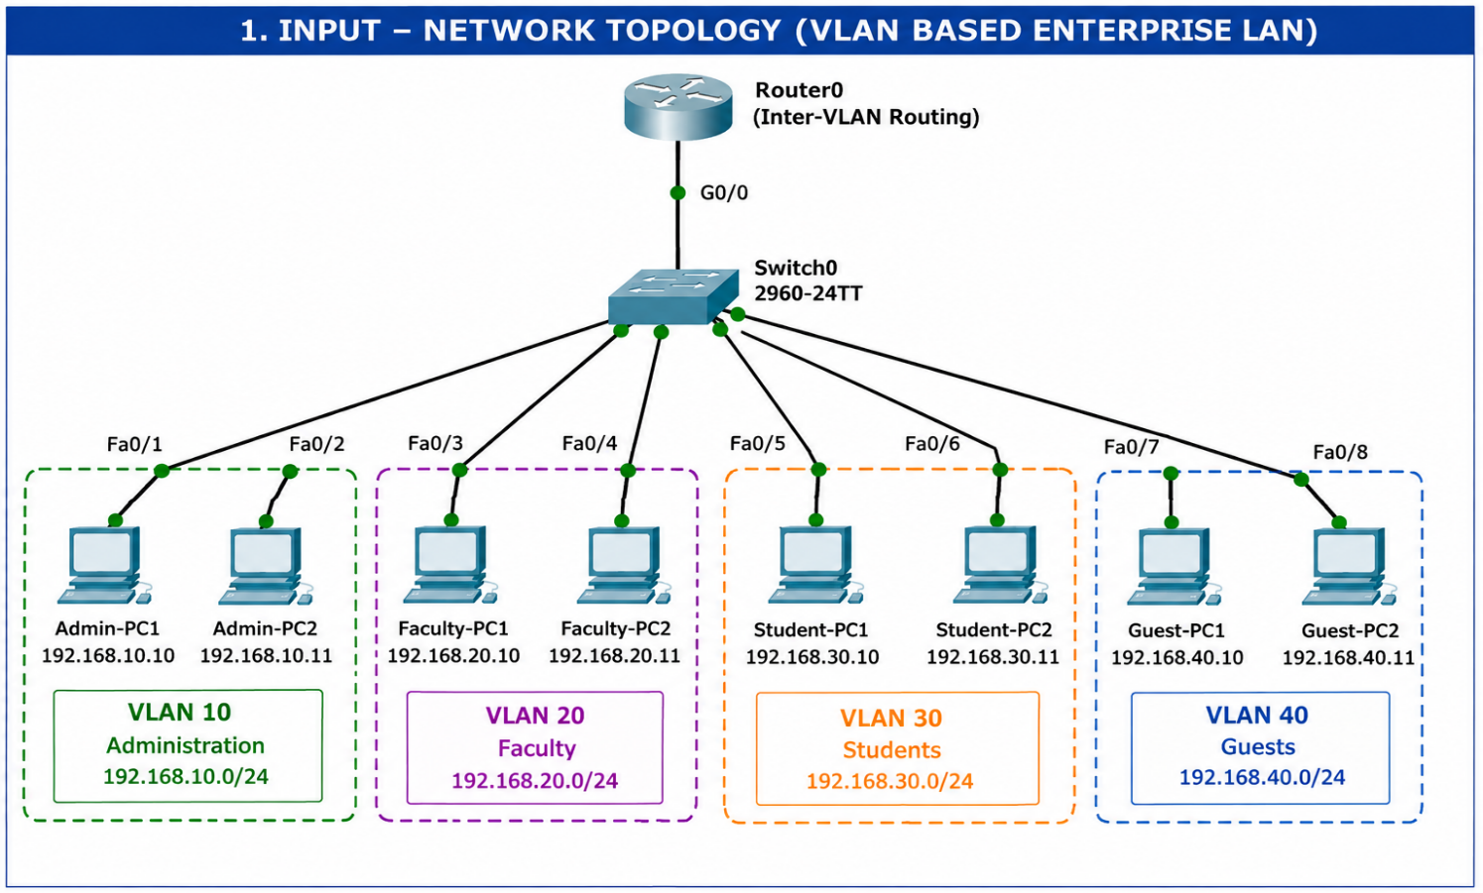
Proposed Network Architecture
VLAN Configuration
VLAN ID | VLAN Name | Department
10 | ADMIN | Administration
20 | FACULTY | Faculty
30 | STUDENTS | Students
40 | GUESTS | Guests
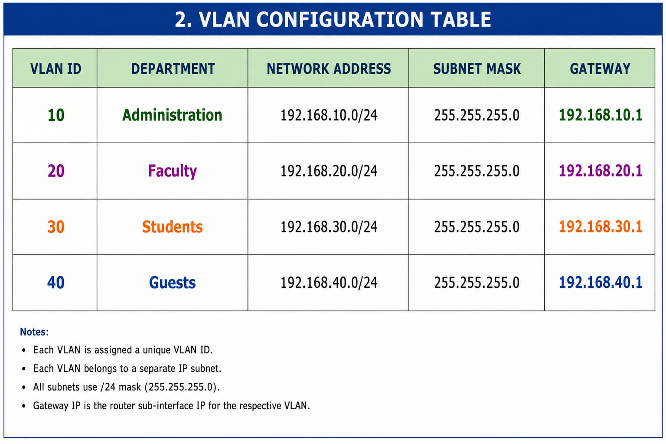
Example PC Addressing
Device | VLAN | IP Address | Gateway
Admin-PC1 | 10 | 192.168.10.10 | 192.168.10.1
Admin-PC2 | 10 | 192.168.10.11 | 192.168.10.1
Faculty-PC1 | 20 | 192.168.20.10 | 192.168.20.1
Faculty-PC2 | 20 | 192.168.20.11 | 192.168.20.1
Student-PC1 | 30 | 192.168.30.10 | 192.168.30.1
Student-PC2 | 30 | 192.168.30.11 | 192.168.30.1
Guest-PC1 | 40 | 192.168.40.10 | 192.168.40.1
Guest-PC2 | 40 | 192.168.40.11 | 192.168.40.1

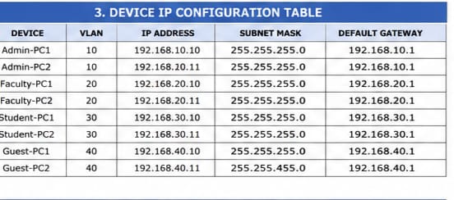

VLAN Configuration Commands

Step 1 – Create VLANs
Switch(config)# vlan 10
Switch(config-vlan)# name ADMIN
Switch(config-vlan)# exit

Switch(config)# vlan 20
Switch(config-vlan)# name FACULTY
Switch(config-vlan)# exit

Switch(config)# vlan 30
Switch(config-vlan)# name STUDENTS
Switch(config-vlan)# exit

Switch(config)# vlan 40
Switch(config-vlan)# name GUESTS
Switch(config-vlan)# exit

Step 2 – Assign Access Ports
Example:
Switch(config)# interface range fa0/1-2
Switch(config-if-range)# switchport mode access
Switch(config-if-range)# switchport access vlan 10
Similarly:
Switch(config)# interface range fa0/3-4
Switch(config-if-range)# switchport mode access
Switch(config-if-range)# switchport access vlan 20
Switch(config)# interface range fa0/5-6
Switch(config-if-range)# switchport mode access
Switch(config-if-range)# switchport access vlan 30
Switch(config)# interface range fa0/7-8
Switch(config-if-range)# switchport mode access
Switch(config-if-range)# switchport access vlan 40

Step 3 – Configure Trunk Port
Switch(config)# interface fa0/24
Switch(config-if)# switchport mode trunk
Switch(config-if)# no shutdown

Inter-VLAN Routing
If a router is used, Router-on-a-Stick can be configured.
Example:
Router(config)# interface g0/0.10
Router(config-subif)# encapsulation dot1Q 10
Router(config-subif)# ip address 192.168.10.1 255.255.255.0

Router(config)# interface g0/0.20
Router(config-subif)# encapsulation dot1Q 20
Router(config-subif)# ip address 192.168.20.1 255.255.255.0

Router(config)# interface g0/0.30
Router(config-subif)# encapsulation dot1Q 30
Router(config-subif)# ip address 192.168.30.1 255.255.255.0

Router(config)# interface g0/0.40
Router(config-subif)# encapsulation dot1Q 40
Router(config-subif)# ip address 192.168.40.1 255.255.255.0
This allows routing between the four VLANs.

4. Use of Modern Tools

Cisco Packet Tracer
Cisco Packet Tracer can be used to design, configure and simulate the VLAN-based enterprise LAN.

Steps
- Open Cisco Packet Tracer.
- Add router and switch.
- Add PCs for each department.
- Connect devices using Ethernet cables.
- Create VLANs.
- Assign switch ports.
- Configure trunk link.
- Configure IP addresses.
- Configure inter-VLAN routing.
- Test connectivity using ping.
- Verify VLAN configuration using show vlan brief.

5. Results and Validation

VLAN Verification
Command:
Switch# show vlan brief
Expected result:
VLAN ID | Name | Status
10 | ADMIN | Active
20 | FACULTY |  | Active
30 | STUDENTS | Active
40 | GUESTS | Active

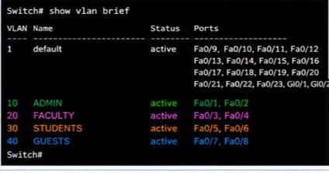
Fig .4 output of VLAN verification

Trunk Verification
Command:
Switch# show interfaces trunk
The trunk interface should show VLANs 10, 20, 30 and 40.
Connectivity Testing

Same VLAN Communication
Example:
Admin-PC1 > ping 192.168.10.11
Expected: Successful.
Faculty-PC1 > ping 192.168.20.11
Expected: Successful.

Inter-VLAN Communication
Example:
Admin-PC1 > ping 192.168.20.10
Expected: Successful when inter-VLAN routing is configured.
Student-PC1 > ping 192.168.40.10
Expected: Successful when routing and appropriate security policies allow it.
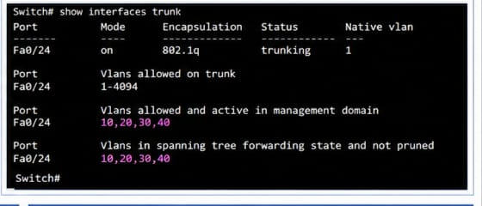

Validation Table
Test | Source | Destination | Expected Result
1 | Admin-PC1 | Admin-PC2 | Successful
2 | Faculty-PC1 | Faculty-PC2 | Successful
3 | Student-PC1 | Student-PC2 | Successful
4 | Guest-PC1 | Guest-PC2 | Successful
5 | Admin-PC1 | Faculty-PC1 | Successful with routing
6 | Faculty-PC1 | Student-PC1 | Successful with routing
7 | Student-PC1 | Guest-PC1 | Successful with routing/policy

Result: VLANs were successfully created, configured and verified. Communication within VLANs was achieved, and communication between VLANs was possible through inter-VLAN routing.
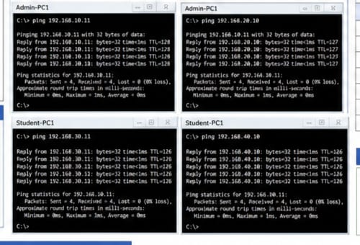
6. Analysis and Engineering Decision

Advantages
- Improves network security.
- Reduces broadcast traffic.
- Separates departments logically.
- Makes network management easier.
- Provides better scalability.
- Allows department-specific security policies.

Limitations
- VLAN configuration requires proper network administration.
- Incorrect trunk or VLAN configuration can cause connectivity problems.
- Inter-VLAN routing requires additional configuration.
- Guest traffic should be controlled using ACLs/firewall policies.

Engineering Decision
A VLAN-based enterprise LAN was selected because it provides better segmentation, security and manageability compared with placing all users in one common LAN.

7. Broader Considerations

Security
VLAN segmentation reduces unnecessary access between departments. Guest users can be isolated from sensitive organizational resources.

Scalability
New users can be added to the appropriate VLAN without redesigning the complete physical network.

Economics
VLANs can provide logical separation using existing network infrastructure, reducing the need for separate physical networks.

Sustainability
Efficient use of existing switches and network infrastructure can reduce additional hardware requirements.

Professional Responsibility
Network administrators should properly secure VLANs, control guest access and regularly verify configurations.

8. Conclusion

The VLAN-based enterprise LAN was successfully designed with four separate VLANs for Administration, Faculty, Students and Guests. Each VLAN was assigned a unique VLAN ID and IP subnet. Access ports and trunk communication were configured appropriately. The network was verified using VLAN and connectivity tests. Inter-VLAN communication was achieved using routing. Overall, the proposed design improves network security, traffic management, scalability and administration.

9. Student Reflection

Through this assignment, I learned how VLANs can be used to logically divide an enterprise network into different departments. I learned how to create VLANs, assign switch ports, configure trunk links and verify connectivity using Cisco Packet Tracer.
If additional time and resources were available, I would improve the network by implementing ACLs, DHCP, firewall rules and separate Internet access policies for the Guest VLAN.

10. References
- Cisco Systems, Cisco IOS XE VLAN Configuration Guide, Cisco Documentation, Accessed: 01 September 2026.
- Cisco Systems, Inter-VLAN Routing Configuration Guide, Cisco Documentation, Accessed: 01 September 2026.
- Cisco Networking Academy, Cisco Packet Tracer – Network Simulation Tool, Cisco, Accessed: 01 September 2026.
- IEEE, IEEE 802.1Q – Virtual LANs and Bridged Networks, IEEE Standards Association, Accessed: 01 September 2026.
- Cisco Systems, Cisco Catalyst Switch Configuration Guide – VLANs, Cisco Documentation, Accessed: 01 September 2026.
- Behrouz A. Forouzan, Data Communications and Networking, McGraw-Hill Education, 5th Edition, 2013.
- Andrew S. Tanenbaum and David J. Wetherall, Computer Networks, Pearson Education, 5th Edition, 2011.
- James F. Kurose and Keith W. Ross, Computer Networking: A Top-Down Approach, Pearson, 8th Edition, 2021.
- Wendell Odom, CCNA 200-301 Official Cert Guide, Volume 1, Cisco Press, 2nd Edition, 2020.
- Cisco Networking Academy, Introduction to Networks – Switching, Routing and Wireless Essentials, Cisco, Accessed: 01 September 2026.

